Applications for people with color blind:

1. Color Blind Pal:

It's an application for IOS and android, it helps people who are color blind see the colors around them. It also lets people with normal vision see what it's like to be color blind.

It's packed with additional features:

* Choose between different types of names for a color, including Common names, Scientific names, and Colloquial names (like "beige")
* See the color's hue, saturation, and value, as well as its exact RGB color code
* Freeze the camera and inspect different colors across the image
* Open any image from your photo library to inspect it
* Turn on your flashlight to get clearer color readings
* Highlight a selected color
* Select a color by pressing it on the screen or by dragging the color spectrum slider
* Draw a stripe pattern over all reddish colors so you can tell what color everything is without changing the colors
* Freeze the camera and experiment with different filters to get an exact sense of what the image really looks like
* Hide all the buttons on the screen so your device becomes a portal through which you see the world in richer color

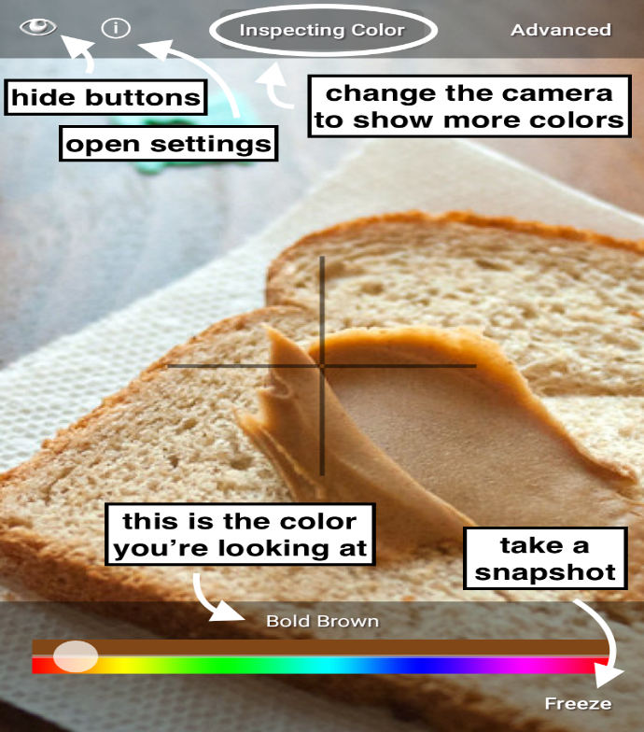

1. Visolve application:

An application for IOS, Android, web, and PC, it transforms colors of the computer display into much brighter colors to help color blind distinguish them

It can execute the following three types of color transformations, filtering, and hatching:

* + 1. Red-Green transform: transform redder colors to brighter and greener colors to darker
    2. Blue-Yellow transform: transforms bluer colors to brighter, and yellower colors to darker.
    3. Saturation increase: increases the saturation of all colors.
    4. Filtering: darkens all colors other than the specified color.
    5. Hatching -- draws different hatch patterns depending on color.

1. Color Binoculars:

A Microsoft developed app helps color blind individuals to distinguish between colors in their everyday lives. Using camera, Color Binoculars replaces difficult color combinations, like red and green, with more easily distinguishable combinations, like pink and green, it supports all types of color blindness

